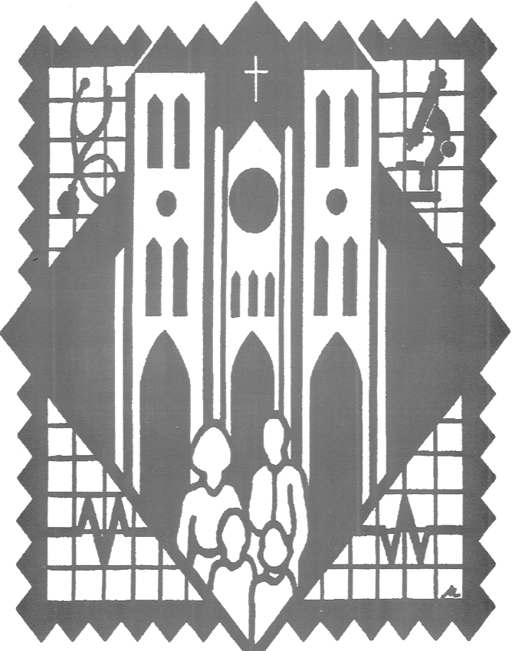
Chairman
Daniel Juarez, M.D.

Co-Chair
Edmundo Garcia, M.D.

Rector, San Fernando Cathedral
Very Rev. Carlos B Velazquez, Rector

Founder
FatherVirgilio Elizondo

Medical Advisory Board
Juan Reyna, M.D.
Roger Campos, D.D.S.
Carlos Orozco, M.D.
Theresa Barrios Ogden, DPM
Joe Alderete
Eugene Rodriguez
Clarissa Rodriguez

Board Member Emeritus
Francisco Cigarroa, M.D.
Gilberto Aguirre, M.D.
Gilbert Ruiz, M.D.
Thomas Uribe, D.D.S.
Sylvia Rodriguez (deceased)

Community Coordinator
Chris Alderete

Executive Director
Diana Guadiano

SAVE THE DATE: Saturday, October 7, 2023- 8:00 AM – 1:00 PM
SPONSOR/EXHIBITOR FORM

Sponsorships/Exhibits Available at the Following Levels

PLATINUM SPONSORS/EXHIBITOR - $5,000 AND ABOVE

Sponsor/Exhibitor listed in two Street Banners posted thirty days
prior to the Health Fair at two prominent inner downtown and
surrounding area sites. Sponsor/Exhibitor listed in 5000 flyers, T-Shirts
and the Programs that guide participants through the testing areas. Booth
space at the Health Fair in a prominent location.

DIAMOND SPONSOR/EXHIBITOR - $3,000 DONATION

Sponsor/Exhibitor listed in 5000 flyers, T-shirts and the Programs
that guide participants through the testing areas. Booth space at
the Health Fair.

GOLD SPONSOR/EXHIBITOR - $1,500 DONATION

Sponsor/Exhibitor listed in 2000 flyers, T-shirts and the Programs that
guide participants through the testing areas. Booth space at the
Health Fair.

SILVER SPONSOR/EXHIBITOR - $500 DONATION

Sponsor/Exhibitor listed in 2000 flyers and the Programs that
guide participants through the testing areas. Table space at
the Health Fair.

BRONZE SPONSOR/EXHIBITOR - $250 DONATION

Sponsor/Exhibitor listed in the Programs that guide participants
through the testing areas. Table space at the Health Fair.

Please remit checks payable to:
San Fernando Cathedral Health & Safety Fair

NOTE: In order to protect their privacy, Sponsors/Exhibitors
are NOT allowed to collect participant’s personal information

